**Delhi’s Air quality Analysis**

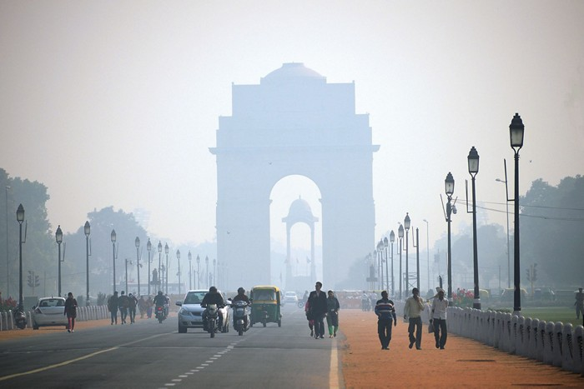

As the capital city of India, Delhi is subject to a high level of pollution year-round. The levels of fine and coarse particulate matter, known respectively as PM2.5 and PM10 are often prevalent in the air, as well as other forms of pollutants and toxic chemicals finding their way into the atmosphere, each with their own detrimental effects on human health. There are an estimated 30.2 million people registered living in Delhi as of 2020, all squeezed into a relatively small area of 1,484km², giving it an extremely high population density.

Delhi managed to take 5th place out of every city worldwide. This placing, along with its 2019 rating falling into the unhealthy bracket, as well as three months out of the year going up a notch into the ‘very unhealthy’ bracket would indicate that Delhi is suffering from extremely high levels of pollution, being one of the world's leaders in poor air quality with extremely high amounts of PM2.5, PM10 and other noxious chemicals and smoke permeating the atmosphere.

**Air Pollution- Everything you need to know**

**What Is Air Pollution?**

Car emissions, chemicals from factories, dust, pollen, and mold spores may be suspended as particles. Ozone, a gas, is a major part of air pollution in cities. When ozone forms air pollution, it's also called smog.

Some air pollutants are poisonous. Inhaling them can increase the chance you'll have health problems. People with heart or lung disease, older adults and children are at greater risk from air pollution. Air pollution isn't just outside - the air inside buildings can also be polluted and affect your health.

**Types of air pollution**

* Particulate matter
* Nitrogen dioxide
* Ozone
* Sulphur dioxide

**Particulate matter**

Particulate matter is a mix of solids and liquids, including carbon, complex organic chemicals, sulphates, nitrates, mineral dust, and water suspended in the air.

PM varies in size. Some particles, such as dust, soot, dirt, or smoke are large or dark enough to be seen with the naked eye. But the most damaging particles are the smaller particles, known as PM10 and PM2.5. PM10 refers to particles with a diameter smaller than 10 microns (10µm) – that’s 100 times smaller than a millimeter. PM2.5 refers to particles with a diameter smaller than 2.5 microns, and these are known as fine particles. The smallest fine particles, less than 0.1 micron in diameter, are called ultrafine particles.

**Nitrogen dioxide (NO2)**

Nitrogen dioxide is a gas and is a major component of urban air pollution episodes. Man-made sources of nitrogen oxides(NO), including nitrogen dioxide(NO2), are vehicles, power stations and heating. Diesel vehicles are major contributors in urban areas. Roadside levels are highest where traffic is busiest.

**Ozone (O3)**

Ozone is a gas composed of 3 atoms of oxygen. In the upper level of the Earth’s atmosphere, it absorbs harmful ultraviolet radiation. Near the ground, ozone is made by a chemical reaction between the sun’s rays and organic gases and oxides of nitrogen emitted by cars, power plants, chemical plants, and other sources. Ozone is usually highest in the spring and summer and lowest in the winter. Ozone levels are highest during the afternoon and are often higher in the country than in towns. Ozone is a major component of summer air pollution episodes.

**Sulphur dioxide (SO2)**

Sulphur dioxide is a colorless gas, with a pungent, suffocating smell. It’s produced by burning Sulphur-containing fuels such as coal and oil. This includes vehicles, power generation and heating. Most Sulphur dioxide comes from electric industries that burn fossil fuels, and from petrol refineries and cement manufacturing. It can travel over long distances and contributes to the formation of ozone.

**About Dataset**

The dataset contains air quality data and AQI (Air Quality Index) at hourly and daily level of various stations across multiple cities in India, but I am using only Delhi's data for analysis.

A tutorial of how AQI is calculated is available here: <https://www.kaggle.com/rohanrao/calculating-aqi-air-quality-index>

The data has been made publicly available by the Central Pollution Control Board: [https://cpcb.nic.in/](https://cpcb.nic.in/%20) which is the official portal of Government of India. They also have a real-time monitoring app: <https://app.cpcbccr.com/AQI_India/>